**Deadlock Detection and Prevention**

**Abstract**

**Deadlocks are a significant challenge in operating systems, databases, and distributed systems, where multiple processes compete for shared resources. A deadlock occurs when a group of processes becomes stuck in a state where they are waiting for resources held by one another, preventing any further progress.**

**This document explores the causes of deadlocks, their conditions, methods for detecting deadlocks, and various techniques for preventing and avoiding them. Furthermore, we discuss real-world scenarios where deadlocks can occur and strategies to mitigate them. Through this study, we aim to provide a thorough understanding of deadlock management techniques that help enhance system performance and reliability.**

**Introduction**

**A deadlock is a situation where two or more processes are unable to proceed because each is waiting for a resource that another holds. This problem is common in multiprogramming environments where processes share limited resources such as CPU time, memory, files, and I/O devices.**

**Deadlocks can significantly degrade system performance and reliability, often leading to system crashes or severe delays in task execution. Understanding deadlock conditions, detection mechanisms, and prevention strategies is crucial for efficient resource management in modern computing systems.**

**Importance of Deadlock Management**

**Deadlocks, if not handled properly, can cause:**

* **System performance degradation.**
* **Resource starvation.**
* **Increased waiting times for processes.**
* **System instability or failure in critical applications.**

**To address these concerns, we need an effective deadlock management strategy, which includes detection, prevention, and avoidance techniques.**

**Deadlock Conditions**

**A system enters a deadlock state if the following four conditions hold simultaneously:**

1. **Mutual Exclusion: At least one resource is held in a non-shareable mode, meaning only one process can use the resource at a time.**
2. **Hold and Wait: A process holding at least one resource is waiting to acquire additional resources held by other processes.**
3. **No Preemption: Resources cannot be forcibly removed from a process; they must be released voluntarily.**
4. **Circular Wait: A set of processes exists such that each process is waiting for a resource held by the next process in the cycle, creating a circular dependency.**

***(Diagram: Venn Diagram Representing Coffman’s Conditions for Deadlock)***



**Deadlock Detection**

**Deadlock detection involves checking the system's resource allocation state to determine if a deadlock has occurred. The most common method for detecting deadlocks is by using a Resource Allocation Graph (RAG).**

**Resource Allocation Graph (RAG)**

* **Nodes: Represent processes and resources.**
* **Edges: Represent allocation (from resource to process) and request (from process to resource).**
* **Cycle Detection: If a cycle exists in the graph, a deadlock is present.**

**Detection Algorithm Steps:**

1. **Construct a Wait-for Graph (WFG) by transforming the RAG.**
2. **Use Depth First Search (DFS) or Karp’s algorithm to check for cycles.**
3. **If a cycle is found, the system is in a deadlock state.**

***(Diagram: Resource Allocation Graph Showing a Deadlock Cycle)***

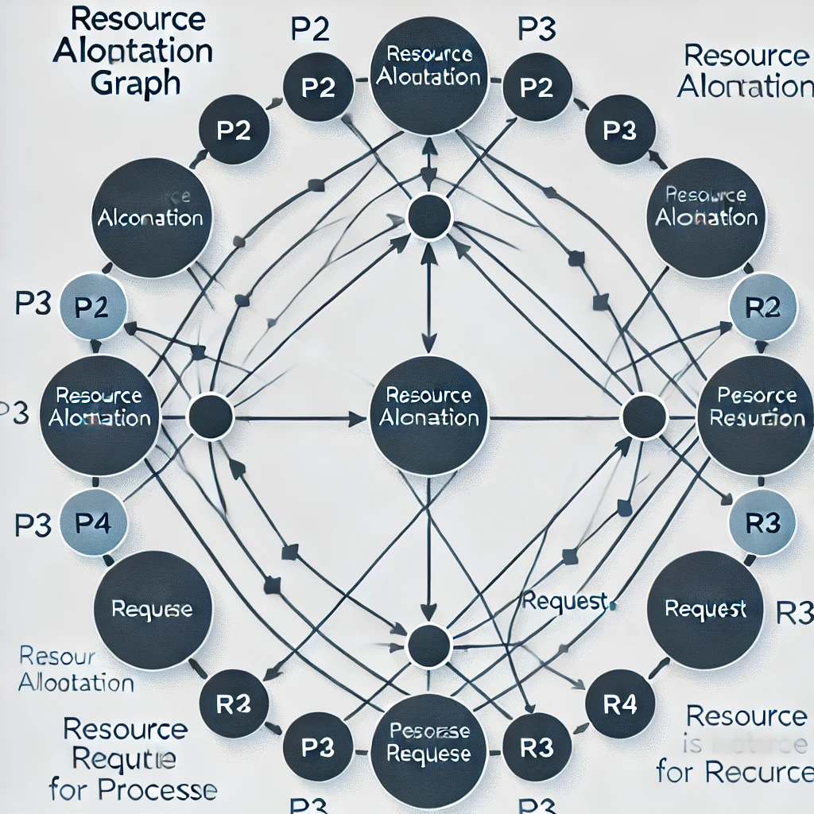

**Advanced Deadlock Detection Methods**

1. **Matrix-based Detection: Using a resource allocation matrix and request matrix to systematically check for cycles.**
2. **Time-stamped Detection: Implementing a time-out mechanism to detect long waiting processes.**
3. **Log-based Analysis: Using system logs to identify deadlock patterns over time.**

**Deadlock Prevention**

**Deadlock prevention techniques aim to eliminate at least one of the four necessary conditions for deadlock.**

**Techniques to Prevent Deadlock**

1. **Eliminating Mutual Exclusion:**
   * **Use spooling where possible (e.g., printer queues instead of direct access).**
   * **Share resources where feasible.**
2. **Avoiding Hold and Wait:**
   * **Require processes to request all necessary resources before execution.**
   * **Implement request all at once policies to reduce partial resource allocation.**
3. **Allowing Preemption:**
   * **Enable the system to reclaim resources when needed.**
   * **Implement priority-based resource allocation.**
4. **Breaking Circular Wait:**
   * **Impose a strict ordering on resource allocation.**
   * **Ensure processes request resources in a predefined sequence.**

***(Diagram: Graphical Representation of Deadlock Prevention Methods)***

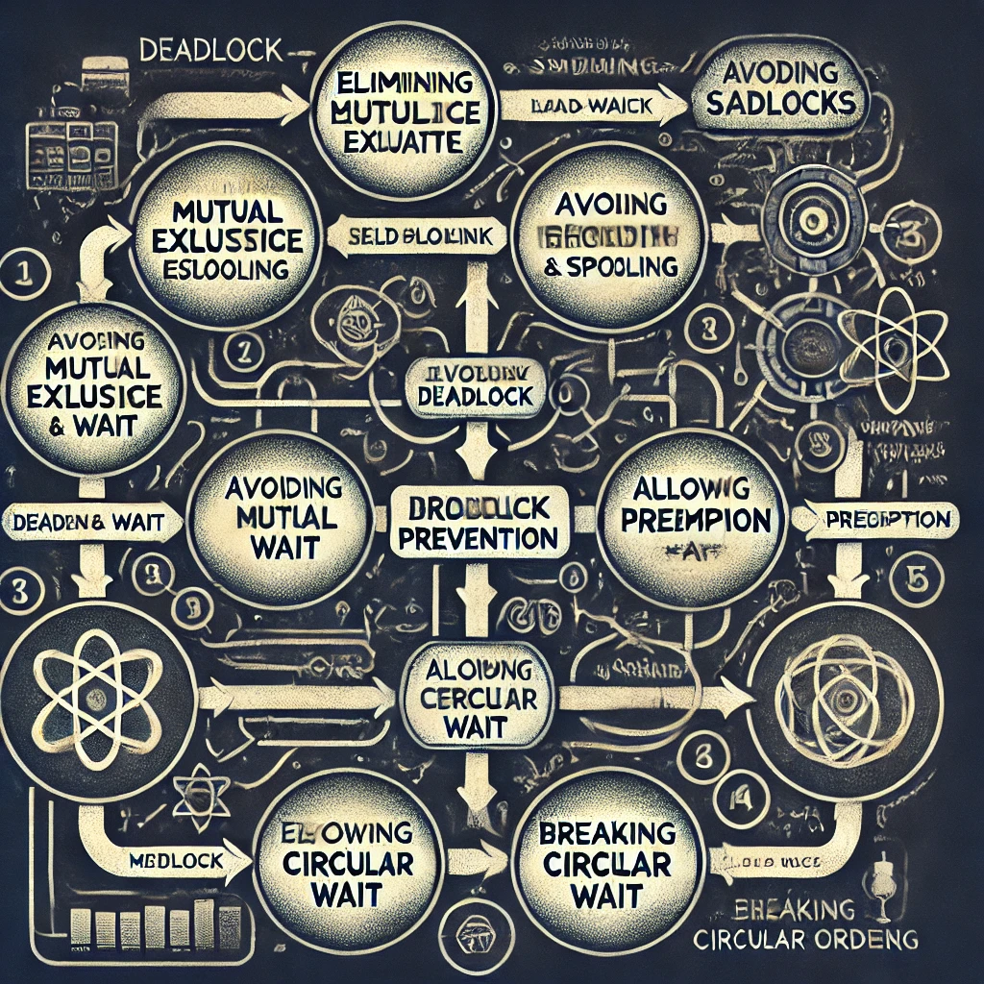

**Deadlock Avoidance**

**Deadlock avoidance ensures that the system never enters an unsafe state. Unlike prevention, it does not eliminate deadlocks entirely but ensures that the system makes safe decisions dynamically.**

**Banker’s Algorithm**

**One of the most effective deadlock avoidance techniques is Banker’s Algorithm, which works as follows:**

1. **The system maintains a safe sequence of processes that can execute without leading to deadlock.**
2. **When a process requests resources, the system checks if granting the request results in an unsafe state.**
3. **If a safe sequence exists, the request is granted; otherwise, it is denied.**

***(Diagram: Example Execution of Banker’s Algorithm)***

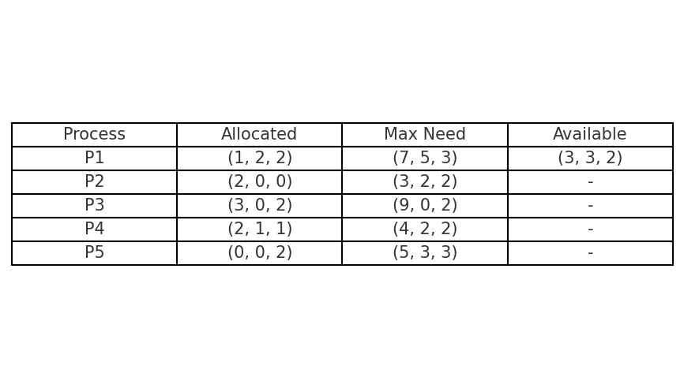

**Other Avoidance Techniques**

* **Resource Allocation Policy: Implementing priority-based allocation to avoid conflicts.**
* **Request Bound Techniques: Limiting the number of requests a process can make.**

**Real-World Examples of Deadlock**

**Deadlocks are not limited to operating systems; they occur in various real-world scenarios, including:**

**1. Traffic Deadlock**

* **Vehicles waiting at an intersection without yielding can lead to circular waiting.**
* **A proper traffic signal system helps prevent such deadlocks.**

**2. Database Transactions**

* **Two transactions locking different rows and waiting for each other result in database deadlock.**
* **Solution: Use deadlock detection mechanisms and implement timeouts.**

**3. Multithreading in Programming**

* **When multiple threads hold locks and wait for each other in a circular fashion, deadlocks occur.**
* **Solution: Use lock ordering and timeouts to break dependency chains.**

***(Diagram: Example of Traffic Deadlock Scenario)***



**Conclusion**

**Deadlocks are a major challenge in computing systems, impacting performance and reliability. Effective deadlock management through detection, prevention, and avoidance strategies is crucial for smooth system operations.**

**By implementing techniques such as the Banker’s Algorithm and proper resource scheduling, we can minimize the risks of deadlocks and improve system efficiency.**

**Future Scope**

**The field of deadlock management continues to evolve with advancements in computing and artificial intelligence. Some potential areas for future research include:**

* **Enhanced detection algorithms for distributed systems.**
* **AI-based approaches for predicting and avoiding deadlocks dynamically.**
* **Advanced resource scheduling techniques to ensure deadlock-free execution in complex systems.**
* **Real-time monitoring tools to detect and resolve deadlocks before they impact system performance.**

***(Diagram: Evolution of Deadlock Handling Techniques)***

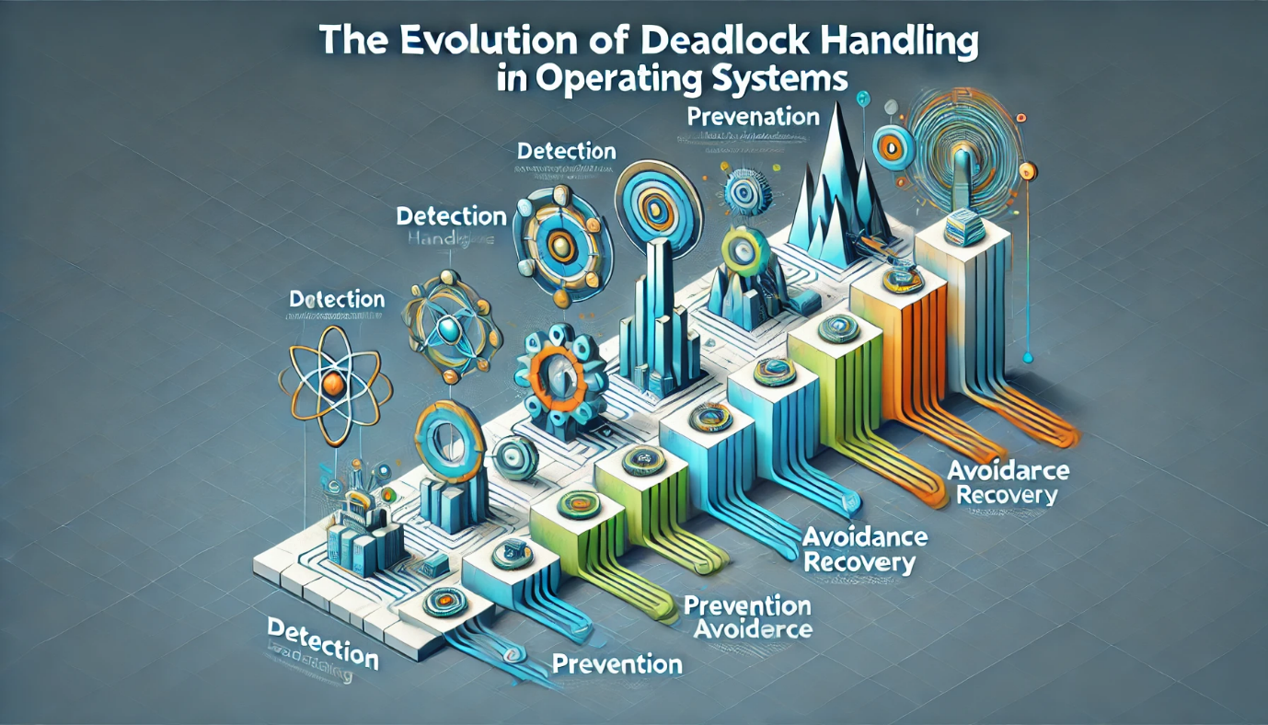

**References**

1. **Silberschatz, A., Galvin, P. B., & Gagne, G. (2021). *Operating System Concepts*.**
2. **Tanenbaum, A. S. (2019). *Modern Operating Systems*.**
3. **Stallings, W. (2020). *Operating Systems: Internals and Design Principles*.**

***(End of Document)***